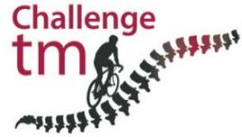

Ted Reddick’s Mont Ventoux Update
No: 2

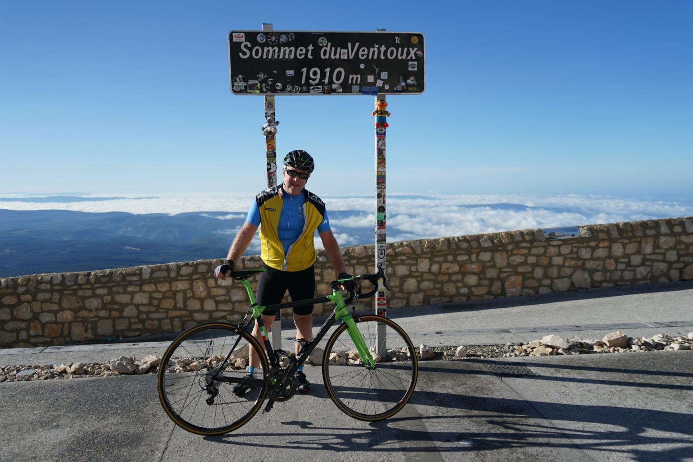

Further to my email last week (written whilst in great discomfort and unable to walk) I can advise that I attempted to complete the climb of Mont Ventoux on Friday 17th September, from the point where I effectively collapsed four days earlier. This entailed a 3.5 mile ride from a standing start at an average gradient approaching 10% (1 in 10).

Despite some minor residual issues from Monday’s ride - not least the fact that I could not mount or dismount my bike without assistance - and strong winds, I am pleased to advise that I did get to the summit (in around 35 minutes).

It was a stunning day and arriving at the top at around 9.15am saw myself, Nick and my two guides/support looking down on the cloud covering the lower slopes.

The last kilometre was extremely testing, as the effect of the gradient was worsened by having to ride a section directly into a, circa, 20 mph headwind. My accompanying rider literally threw his bike onto the side of the road and ran alongside me to ensure that I could be caught/assisted if the effects of TM took over but (despite some pretty loud vocal expressions of discomfort) I managed to clear the penultimate bend before things started to ease slightly before the top.

This proved categorically that Monday’s problems were not caused by anything other than the effects of TM and I actually climbed to the top in a gear far higher than a majority of riders we encountered on both days (the majority of whom also stopped a number of times). I cannot say it was easy but I rested completely on Tuesday and Thursday in order to both recover and prepare for the Friday attempt and had an unforgettable 28 mile on the Wednesday to test how I was, two days after the initial problems arose.

The range of emotions over the last week has been extensive, but I hope that all who supported me (now over £31,000) will be able to honour their pledges given that I did succeed in my goal - despite some pretty serious issues arising during the first attempt. The photo’s below will hopefully emphasise the scale of what I manged to achieve and, again, many thanks for your support.
