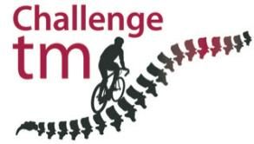

Ted Reddick’s Mont Ventoux Update

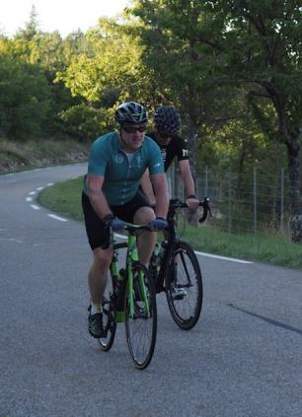

Firstly many thanks for your support to my efforts to raise awareness and funds for transverse myelitis.

Regretfully I have to advise that my attempt to climb the mountain non-stop yesterday failed after almost exactly 2 hours (my longest single ride since paralysis) and 13.67 miles, at an altitude of 4,818 ft - some 3.5 miles short of the summit.

Needless to say I was extremely disappointed, but it’s clear that it was the affects of my condition that caused me to stop as I was completely incapable of lifting myself out of the saddle to climb around a corner and, after stopping, I had to be caught by one of my support team and was unable to support my weight (collapsing and unable to walk for many hours). Things were that bad that we had to remove the saddle and seatpost from my bike, in order for it to be slid from underneath me to dismount!

Basically my legs ceased to function for a number of hours and my condition deteriorated to a level not dissimilar to that I endured during the early stages of my ‘recovery’ from paralysis. I am walking again today but still incapable of standing/sitting without support - a situation I encountered following a simulation of the ride some weeks ago.

It is clear that my general physical fitness is good, as my average heart rate for the climb was around 118 bpm, with TM being the ultimate cause of my failure to compete the challenge (which was, in any event, never meant to be easy!).

My original objective was to ride to the summit non-stop and obviously that has not happened but, as of today, I am thinking of recommencing the ride on Friday with a view of picking up from where I stopped and attempting to ride to the summit (undoubtedly the hardest section of the whole climb).

I will let my supporters be the judge of whether or not your pledges of support will stand after this week but I thought best to update you that I will not be trying to ride the full climb again as it’s clear that my body will not be able to endure such an effort over such a short period.

The photo’s below show me literally seconds before everything stopped and one of my team grabbing me before I collapsed:

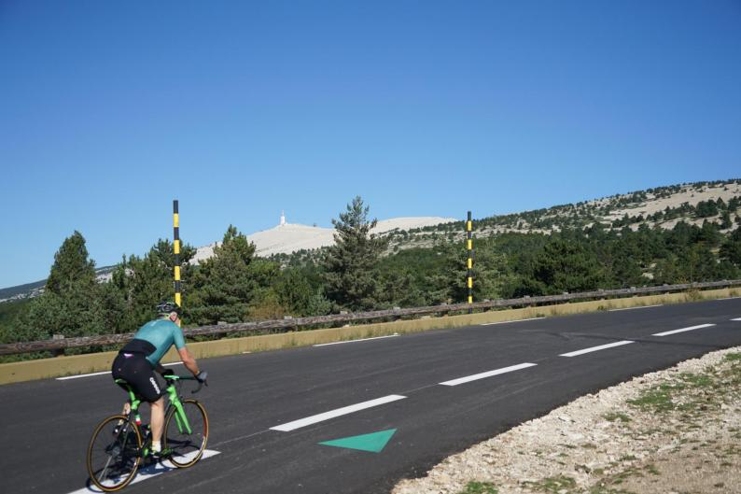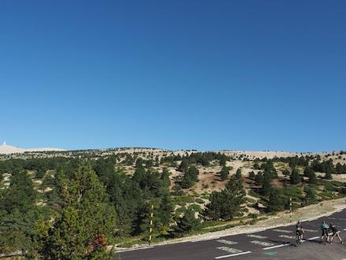
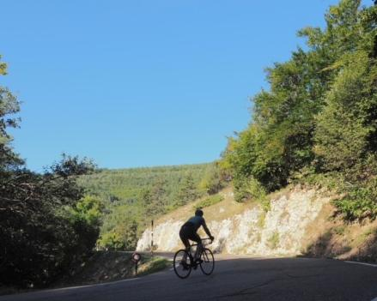 Climbing up from Sault emulating the logo!

